The golden ratio

The Golden ratio is an Ancient Greek theory used to depict symmetry in plants animals and buildings, it is also known as the divine proportion. It is also understood as the 1:1.68 ratio and is a naturally occurring sequence of numbers that can be found almost anywhere in nature.

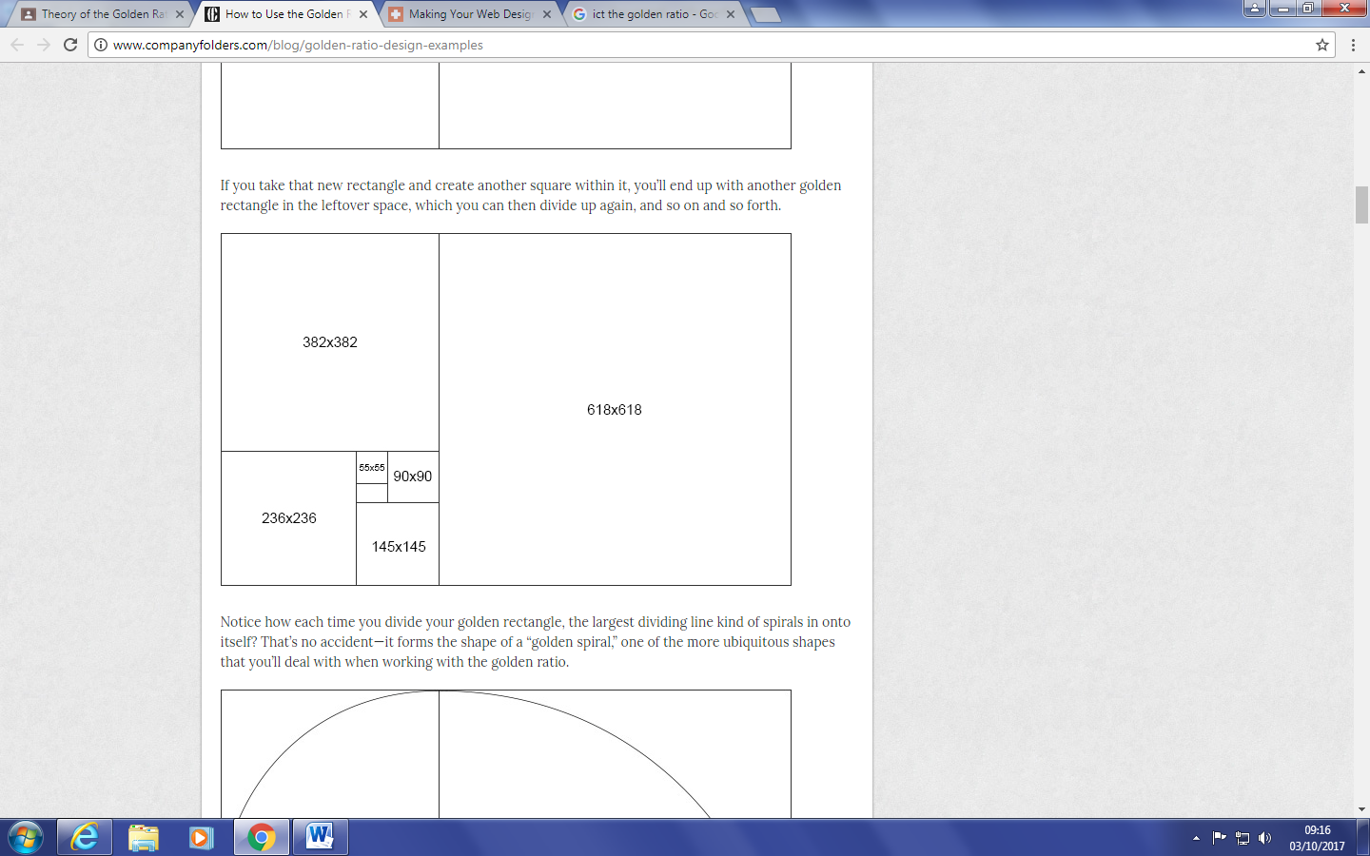

Examples of the ‘golden ratio’

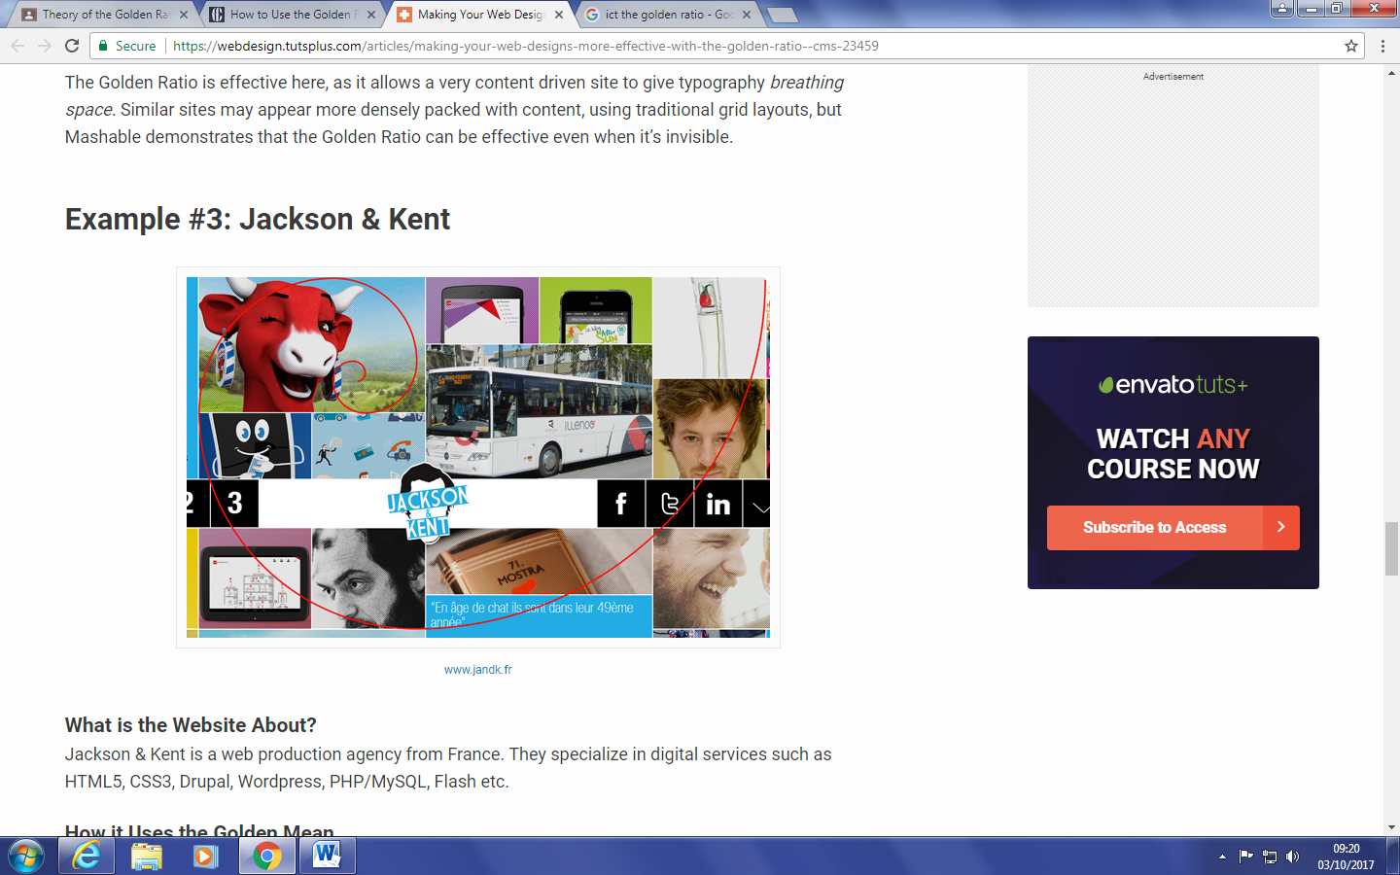

The Jackson & Kent website use the golden ratio in there grid design layout. This encourages the viewer to scan the website horizontally and the various grid sizes keep the page visually attractive.

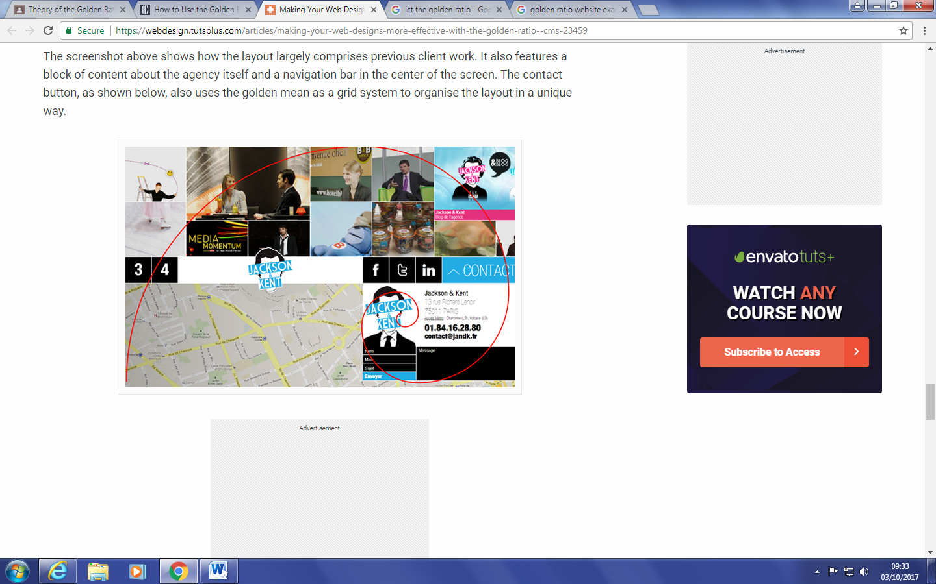

This second page uses the golden ratio on their contact button and uses this area to encourage the viewer’s eyes to finish scanning on the contact details.